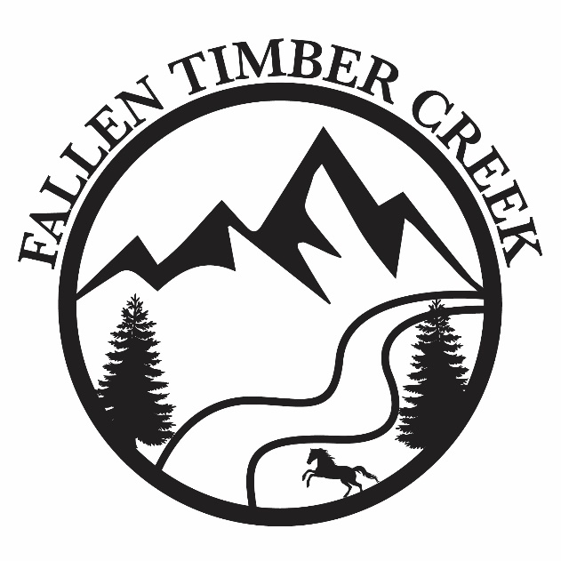

Born and raised proud Albertans, farming has played a major role in our family for generations. In the northernmost part of Alberta’s boreal forest, we farm beautiful organic land. Organic food is very important to us and we have been supplying quality organic grain for years. As our family grew, we found it increasingly difficult to find the healthiest and most nutritious flour. After a lot of research and hard work we are proud to be able to supply stone-ground, organic flour and bring it from our farm to your table.

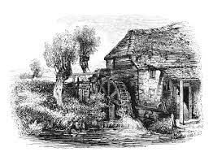

[**www.**FallenTimberCreekFlourMill**.com**](http://www.FallenTimberCreekFlourMill.com)

**Email:** [fallentimbercreekflourmill**@gmail.com**](mailto:fallentimbercreekflourmill@gmail.com)

Phone: 587-444-3332

Sundre, AB

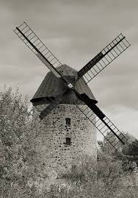

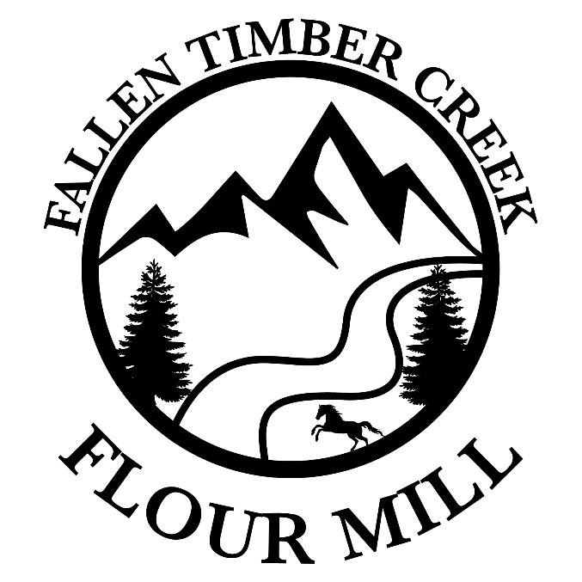

Our farm has been **certified organic** for over 20 years. We grow our own wheat and now mill it into flour using only our stone mill.

**No chemicals**

**No fertilizers**

**No sprays**

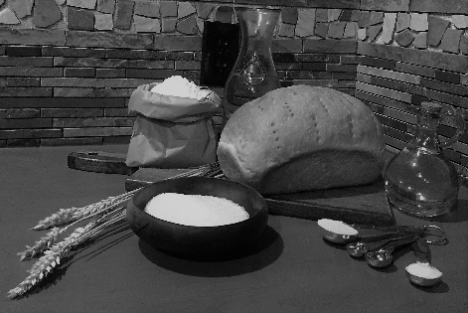

**In the early 1900s, shortly after the high-speed roller mills came to America, people started protesting them because of the massive loss in nutrition and the harmful effects of refined flour. Due to the extreme differences in nutritional quality between the two milling processes, in 1920 the head of the FDA, Harvey Wiley, tried to outlaw refined and bleached white flour.** Part of the roller mill process is creating high heat which strips natural nutrients from the flour. This is why producers have to ‘enrich’ it. However, mass production was more important, so roller mills became the norm.

**If ground slowly, stone-ground flour stays at a cool temperature. Which then keeps those essential vitamins, minerals and nutrients in the flour. We watch the temperature of our flour very closely as we mill, adjusting the stones and wheat flow as needed, to ensure it does not get heated.**

Wheat is a nutrient rich food source. Often people find an intolerance to wheat flour because of the chemicals, sprays and the way that it is processed.

Stone-ground organic wheat flour contains numerous vitamins, minerals, prebiotics, and essential enzymes. When milled cool, stone-ground flour contains the entire B complex, other than vitamin B12. This contributes to why stone-ground flour gives so much energy.

Wheat germ is promoted as a health food; a few reasons are because it has powerful antioxidant properties, it boosts the immune system, and reduces insulin resistance.

We have found that many people who cannot eat regular flour can consume organic stone-ground flour without any side effects. The cool stone milling process keeps the wheat in its original form.

**Customer review:**

“I bought a bag of your whole wheat flour from you recently. I have been very sensitive to any wheat products as they always cause symptoms within an hour or two of eating. Therefore, I have been limited to eating gluten-free products for more than ten years. But after two weeks of eating it, I have discovered that I can eat anything made with your whole wheat flour, and so far, I have had no reaction and have detected no sign of sensitivity to it.”

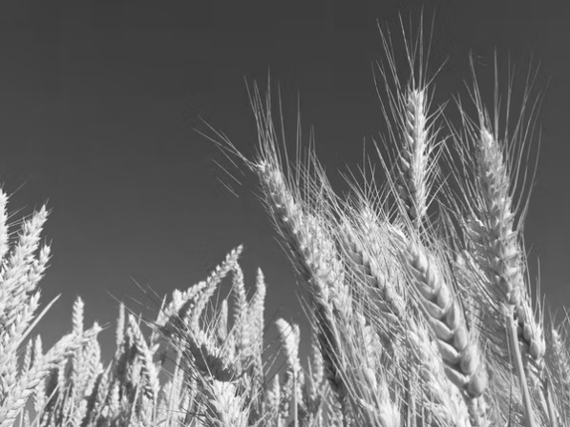

Our certified organic wheat is grown with **NO** chemicals, sprays, fungicides, pesticides or fertilizer. The grain is unmodified and completely free of any chemicals whatsoever.

We do crop rotation and summer follow to ensure the land is not depleted of nutrients.

We are certified organic, so we do not desiccate the wheat to speed up the ripening process. Our wheat has to live its full life and ripen naturally before we harvest it. We then stone mill it cool, which keeps all the ‘good stuff’ in its natural state. You can even taste the difference!

